|  |
| --- |
| Department of Software Engineering  Mehran University of Engineering and Technology, Jamshoro |

|  |  |  |  |
| --- | --- | --- | --- |
| Course: SW321–Computer networks and management | | | |
| Instructor | Aisha Ashraf | **Practical/Lab No.** | 03 |
| Date |  | **CLOs** | CLO-3: P5& CLO-4: P3 |
| Signature |  | **Assessment Score** | 1 Mark |

|  |  |
| --- | --- |
| Topic | To familiar with ping and tracert commands |
| Objectives | * To learn various CMD network commands |

|  |
| --- |
| Lab Discussion: Theoretical concepts and Procedural steps |

Some of the useful network commands using a simple command prompt and their usage are listed below. To get started with these commands all you need to do is open your command prompt and execute them.

1. **ipconfig:**You can find your IP address from the Control Panel, but it takes a few clicks to get there. The ipconfig command is a fast way of determining your computer’s IP address and other information, such as the address of its default gateway—useful if you want to know the IP address of your router’s web interface. To use the command, just type ipconfig at the Command Prompt. You’ll see a list of all the network connections and the respective addresses your computer is using. Look under “Wireless LAN adapter” if you’re connected to Wi-Fi or “Ethernet adapter” if you’re connected to a wired network.

**Execution:*ipconfig***

Some other variants of this command are as follows:

***ipconfig /displaydns:*** Running this command would display all the DNS information.

***ipconfig /flushdns:*** Delete all DNS entries.

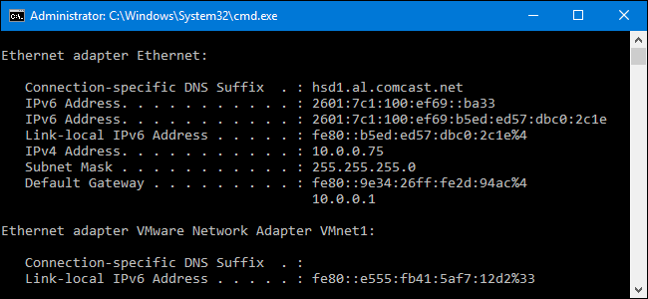

1. **ping:** ping stands for **“packet internet gopher”**. This command is particularly used to troubleshoot network connection issues as this specifies that whether your computer is able to connect to the destination server or not. When you ping a device you send that device a short message, which it then sends back (the echo).

**Execution: *ping hostname*** or ***ping ipaddress***

Example: **ping www.google.com** or **ping 216.58.208.68**

You can use either a name or the actual IP address. The server at that IP address (in our case, the Google server) will respond and let you know it’s received them. You’ll be able to see if any packets didn’t make it to the destination—perhaps you’re experiencing packet loss—and how long it took to get the response—perhaps the network is saturated and packets are taking a while to reach their destinations.

1. **tracert:** [This](https://www.howtogeek.com/134132/how-to-use-traceroute-to-identify-network-problems/) command traces the route it takes for a data packet to reach a destination and shows you information about each point (called hop) along that route. For example, if you run tracert howtogeek.com, you’ll see information about each node the packet interacts with on its way to reach our server. If you’re having issues connecting to a website, tracert can show you where the problem is occurring.

**Execution: *tracert ipadress*** or ***tracert hostname***

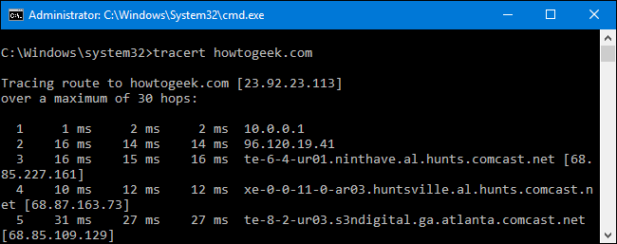

1. **net view:**This command is used to view all the devices connected to your network as well as the shared resources such as printers etc. on the network.

**Execution: *net view***

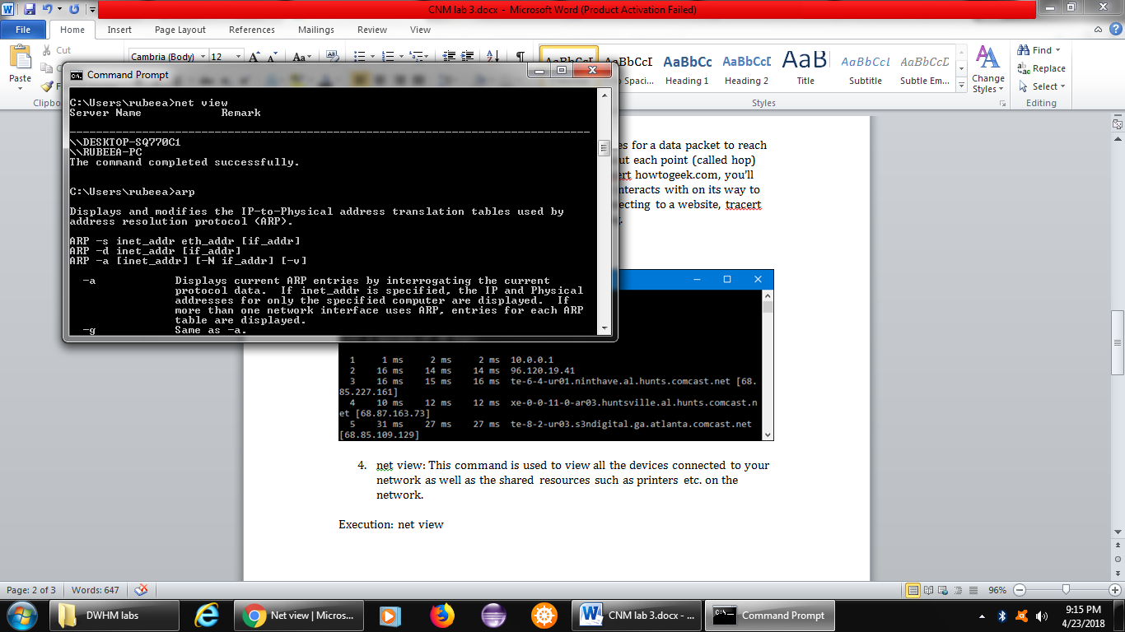

1. **arp:**The arp command shows ip-addresses to MAC addresses translation tables. This command must be used with a command line option **arp -a** is the most common.

**Execution: *arp-a***

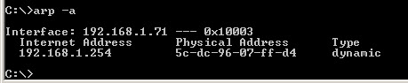

|  |
| --- |
| Lab Tasks |
| Submission Date: |

1. Execute the above mentioned commands and display the outputs.
2. Find and explain a network command that changes the ipaddress of your computer from your command prompt. Change the ipaddress and display the output.